
www.kingston-saddlery.com
QUALITY ALWAYS WINS
875 STILLWATER ROAD SUITE 200 WEST SACRAMENTO, CA 95605
Phone: (916)996-0711 Fax: (530)753-4505
E-mail: kingstonsaddlery@yahoo.com & sales@kingston-saddlery.com
ASSEMBLY OF THE CARRIAGE
INSTALL HOOKS-------------------------------------------------------------------------------------------------- -2-
Groupware ------------------------------------------------------------------------------------------------------ -2-
Installation ------------------------------------------------------------------------------------------------------ -2-
Finished Picture ------------------------------------------------------------------------------------------------ -2-
INSTALL AXLE ---------------------------------------------------------------------------------------------------- -3-
Groupware ------------------------------------------------------------------------------------------------------ -3-
Installation ------------------------------------------------------------------------------------------------------ -3-
Finished Picture ------------------------------------------------------------------------------------------------ -3-
INSTALL WHEELS ------------------------------------------------------------------------------------------------ 4-
Groupware ------------------------------------------------------------------------------------------------------ -4-
Installation ------------------------------------------------------------------------------------------------------ -4-
Finished Picture ------------------------------------------------------------------------------------------------ -4-
INSTALL THE BRACKET --------------------------------------------------------------------------------------- 5-
Groupware ------------------------------------------------------------------------------------------------------ -5-
Installation ------------------------------------------------------------------------------------------------------ -5-
Accomplishment ----------------------------------------------------------------------------------------------- -5-
INSTALL SEAT ----------------------------------------------------------------------------------------------------- 6-
Groupware ------------------------------------------------------------------------------------------------------ -6-
Installation ------------------------------------------------------------------------------------------------------ -6-
INSTALL THE TURNING BAR -------------------------------------------------------------------------------- -7-
Groupware ------------------------------------------------------------------------------------------------------ -7-
Installation ------------------------------------------------------------------------------------------------------ -7-
Finished Picture ---------- 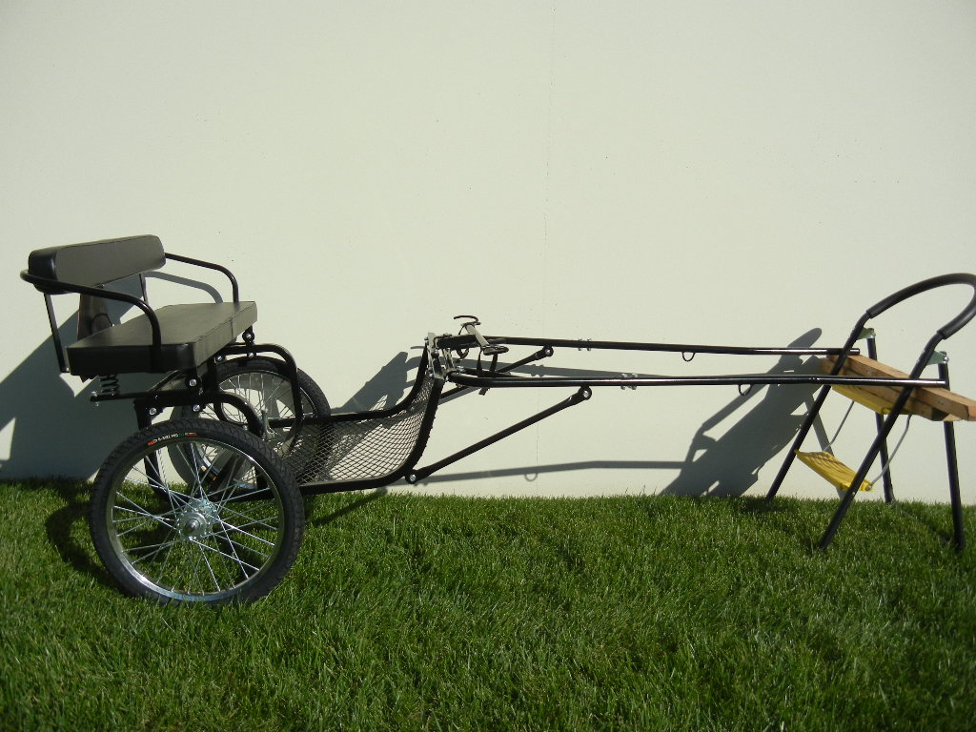
Product code:C2201.48-55, C2211.48-55, C2181.48-55, C2241.48-55, C2201.53, C2211.53, C2181.53, C2241.53
Remark:

Color: Black
Strong, rugged design with wood floor, hardwood (or iron) singletree and a comfortable cushioned seat for two with a backrest. Open design for easy entry and exit (can appended railing).
We offer solid rubber tires, motorcycle wheels, chrome rim 24" wheels (20" on Mini size). Metal shafts standard.

1、INSTALL SHAFTS HOOKS
GROUPWARE
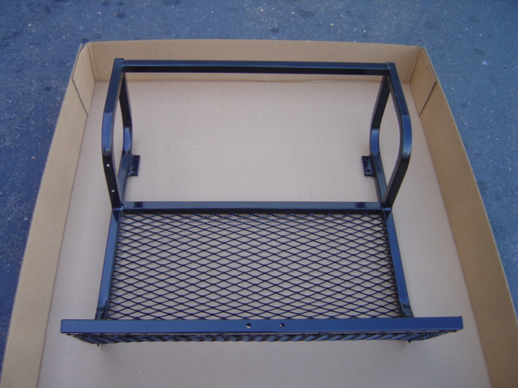 | 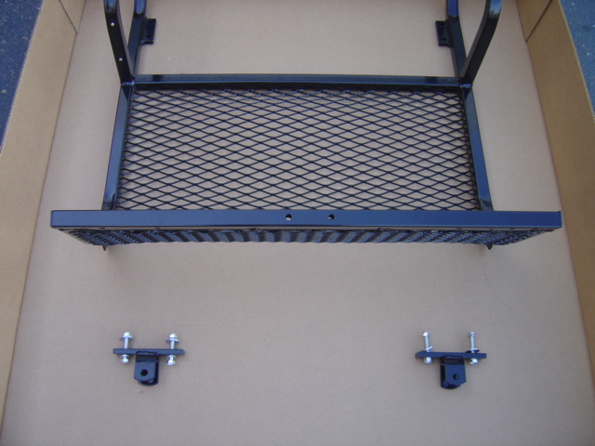 |  | 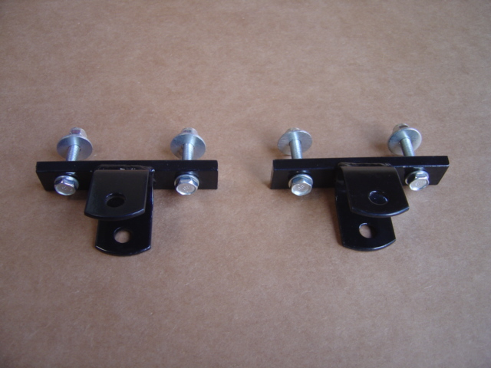
（1）BODYWORK | （2）BODYWORK AND A PAIR OF HOOKS |  | （3）A PAIR OF HOOKS
INSTALLATION
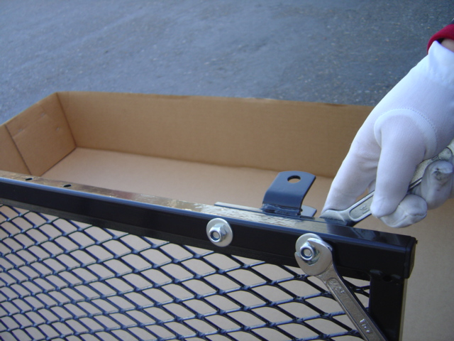 |  | 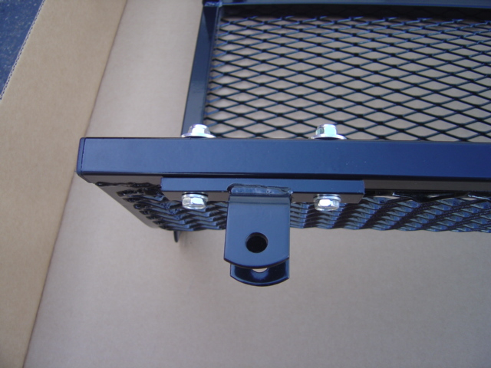
Tighten (3) into (1) with spanners. |  | Finished as picture (forward for hold shafts)
FINISHED PICTURE
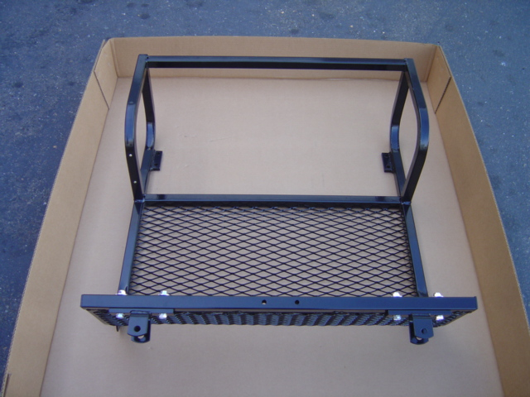
（4）BODYWORK + HOOKS
2、INSTALL AXLE

GROUPWARE
 | 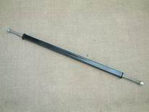 |  | 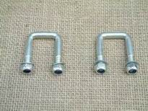
（1）BODYWORK | （2）AXLE |  | （3）U-STYLE TIGHTEN PIECE (×2)
INSTALLATION
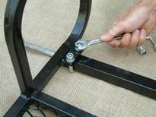 |  | 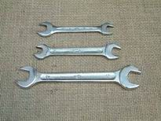
Tighten (2) into (1) by (3) with spanner. |  | ACCESSORIES: A SET OF 3 SPANNERS
FINISHED PICTURE
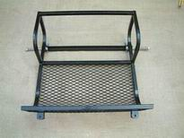
（4）BODYWORK + AXLE

3、INSTALL WHEELS

GROUPWARE
 |  | 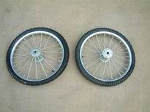
（4）SEAT + AXLE |  | （5）WHEELS（×2）
INSTALLATION
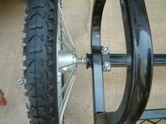 | 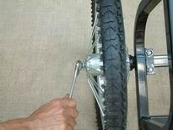
Put the washer on the axle and then install the wheels (5). | Again put the washer on the axle outside, and tighten it with the nut.  NOTICE: THE NUT SHOULD NOT BE TOO TIGHT. |  | Another wheel is installed just as the same procedure.
FINISHED PICTURE
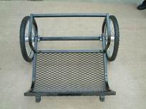
（6）BODYWORK + AXLE + WHEELS

4、INSTALL THE BRACKET

GROUPWARE
 |  | 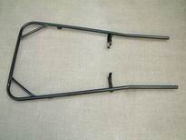
（6）BODYWORK+AXLE+WHEELS |  | （7）BRACKET
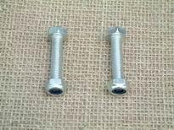 |  | 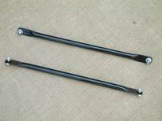
（8）TIGHTEN NUT |  | （9）SHAFT（×2）
INSTALLATION
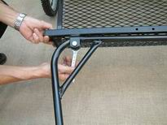 | 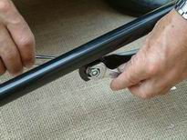 |  | 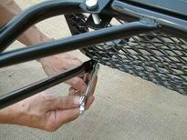
Install (7) to the U-style groove in front of (6) and tighten it with (8). | Fix one side of (9) on (7) by nut. |  | Fix the other side of (9) on (6) by nut.
ACCOMPLISHMENT
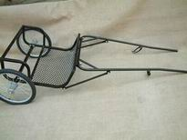
（10）MAIN CARRIAGE ASSEMBLY
5、INSTALL SEAT

GROUPWARE
 | 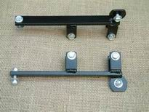 | 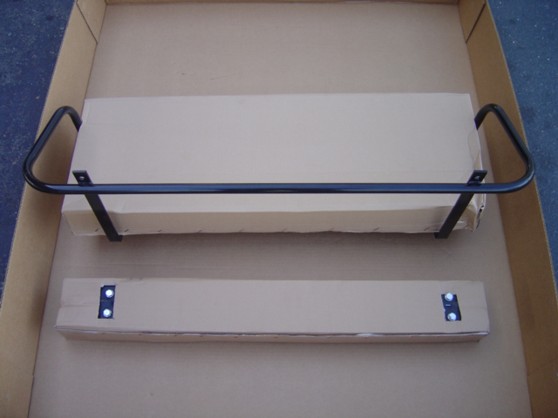
（10）MAIN CARRIAGE ASSEMBLY | （11）SEAT CONNECTION AND SUSTAINTATION PIECES（×2） | （12）SEAT (BE CAREFUL TO REMOVE THE COVER, DON’T USE KNIFE).
INSTALLATION
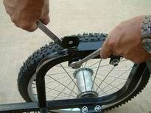 | 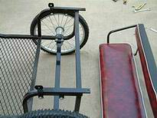 | 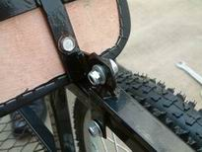
Fix one side of (11) on the horizontal frame of the (10) by nut, and tighten it with spanner. | Fix the other side of（11） | Fix the transverse nut of (12) with (11).  NOTICE: NOT SO TIGHTEN
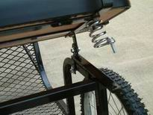 | 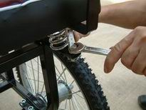 | 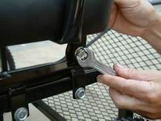
Set the bolt to the anti shake spring of (12), revolve (12) so that the bolt can be put into the hole of (11) | Fix the nuts on lengthways. | Fix the transverse nut.

6、INSTALL THE TURNING BAR

GROUPWARE
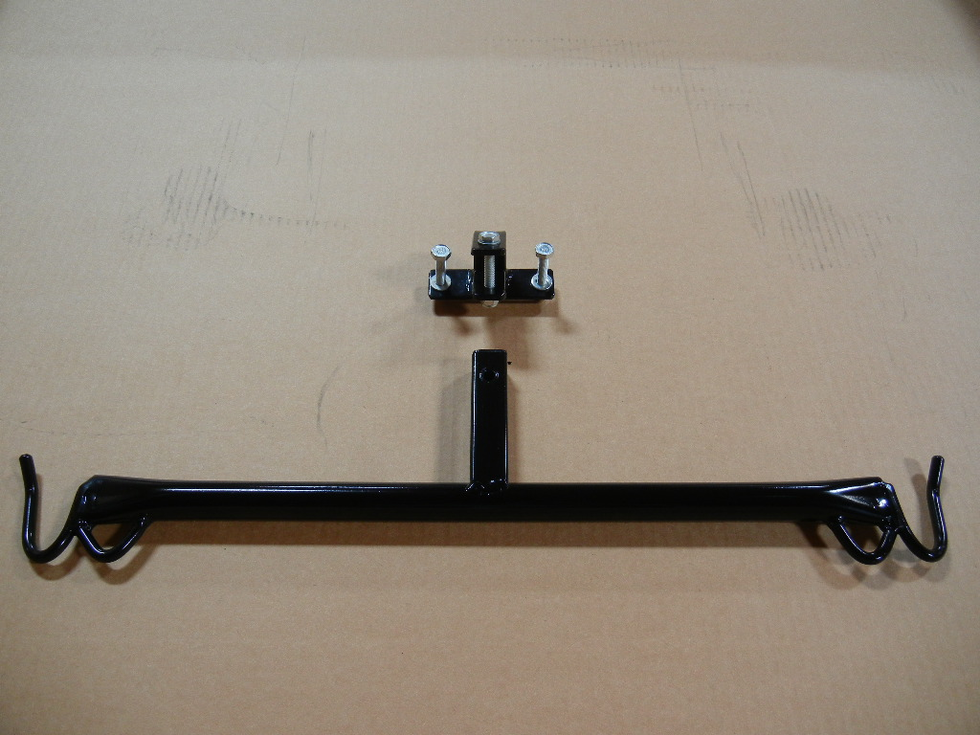 |  | 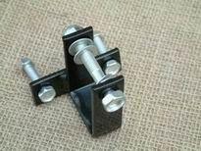
（13）TURNING BAR |  | （14）BAR CONNECION
INSTALLATION
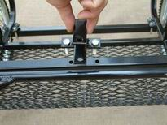 | 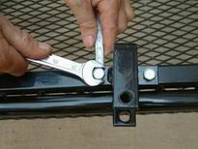
Fix (14) on the front rail of bodywork by bolt. | Tighten（14）
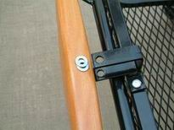 | 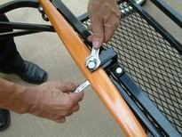
Add two washers on the top and bottom of the (13), put them into the groove (14). | Tighten (13) and (14)  NOTICE: NOT SO TIGHT TO MAKE SURE THE TURNING OF (13).
FINISHED PICTURE

